GENERAL CONFEDERATION OF LABOR OF VIETNAM

**TON DUC THANG UNIVERSITY**

**FACULTY OF INFORMATION TECHNOLOGY**



**REQUIREMENT ANALYSIS & DESIGN (RAD)**

**JEWELRY ONLINE SALES SYSTEM**

*Instructing Lecturer*: **Mr. PHAM THAI KY TRUNG**

*Student’s name*: **LƯU THANH DUY – 51600021**

**NGUYỄN VĂN HẢI – 51600022**

Class: **16050311**

Course: **20**

**HO CHI MINH CITY, 2019**

GENERAL CONFEDERATION OF LABOR OF VIETNAM

**TON DUC THANG UNIVERSITY**

**FACULTY OF INFORMATION TECHNOLOGY**



**REQUIREMENT ANALYSIS & DESIGN (RAD)**

**JEWELRY ONLINE SALES SYSTEM**

Instructing Lecturer: **Mr. PHAM THAI KY TRUNG**

Student’s name: **LƯU THANH DUY - 51600021**

**NGUYỄN VĂN HẢI - 51600022**

Class: **16050311**

Course: **20**

**HO CHI MINH CITY, 2019**

ACKNOWLEDGEMENT

We would like to send our most sincere thanks to lecturer Pham Thai Ky Trung.

During the teaching process, he devoted himself to teaching, providing and

imparting important and necessary knowledge so that we can apply and complete the project in the best way.

Besides, we would like to thank the teacher for guiding, supporting and reminding our group to be able to complete the project on schedule.

We sincerely thank you!

**THE PROJECT WAS COMPLETED AT TON DUC THANG UNIVERSITY**

I commit that this product be long to us with the guardian of Mr. Pham Thai Ky Trung. The content of research, result of this project is honest and has not been published in any form before. The data in the tables for analysis, comment and evaluation were collected by the author from various sources in the reference section.

Besides, our project used many kinds of comments, assessments as well as data from another authors, organizations. This project has original quotes and annotations.

**If any fraud is detected, I will take full responsibility for the contents of my project**. Ton Duc Thang University is not involved to any violations of copyright and copyright caused by me during implementation (if any).

*Ho Chi Minh City, November 17th 2019*

*Author*

*(Sign and write full name)*

*Luu Thanh Duy*

*Nguyen Van Hai*

EVALUATION OF INSTRUCTING LECTURER

**Confirmation of the instructor**

_______________________________________________________________________________________________________________________________________________________________________________________________________________________________________________________________________________________________________________________________________________________________________________________________________________

*Ho Chi Minh City, November 17th 2019*

*(Sign and write full name)*

**The assessment of the teacher marked**

_______________________________________________________________________________________________________________________________________________________________________________________________________________________________________________________________________________________________________________________________________________________________________________________________________________

*Ho Chi Minh City, November 17th 2019*

*(Sign and write full name)*

ABSTRACT

The Online Shopping is a web based on application intended for online retailers. The main objective of this application is to make it interactive and its ease of use. It would make searching, viewing and selection of a product easier. It contains a sophisticated search engine for users to search for products specific to their needs. The search engine provides an easy and convenient way to search for products where a user can Search for a product interactively and the search engine would refine the products available based on the user’s input. The user can then view the complete specification of each product. The application also provides a drag and drop feature so that a user can add a product to the shopping cart by dragging the item in to the shopping cart. The main emphasis lies in providing a userfriendly search engine for effectively showing the desired results and its drag and drop behavior.

TABLE OF CONTENTS

**LIST OF SYMBOLS AND ABBREVIATIONS**

**Symbols**

**Abbreviations**

LIST OF TABLES, FIGURES, GRAPHICS

**LIST OF FIGURES**

**LIST OF TABLES**

CHAPTER 1 – INTRODUCTION

Shopping has long been considered a recreational activity by many. Shopping online is no exception. The goal of this application is to develop a web based on interface for online retailers. The system would be easy to use and hence make the shopping experience pleasant for the users. The goal of this application is:

* To develop an easy to use web based on interface where users can search for products, view a complete description of the products and order the products.
* A search engine that provides an easy and convenient way to search for products specific to their needs. The search engine would list a set of products based on the search term and the user can further filter the list based on various parameters.
* Drag and Drop feature which would allow the users to add a product to or remove a product from the shopping cart by dragging the product in to the shopping cart or out of the shopping cart.
* A user can view the complete specification of the product along with various images and also view the customer reviews of the product. They can also write their own reviews.

CHAPTER 2 – ANALYSIS PRESENTATION

2.1 Actors

* Web Customer:
* New Customer: will be an official customer and can order after successful registration.
* Register Customer: customers registered as official members and are allowed to place orders
* Shop Owner: perform product management and have the right to add, delete, edit that related to the staffs as well as he can register account and review report of clerk.
* Credit Payment Service: provide payment services to the store by credit card
* PayPal: provide payment services to the store by paypal
* <<Service>>Authentication: this is a service use to authenticate the credentials, usually account names and passwords of customer.
* Clerk: has function as sales, payment and product management after measuring the report every day to the shop owner.

2.2 Use case diagram

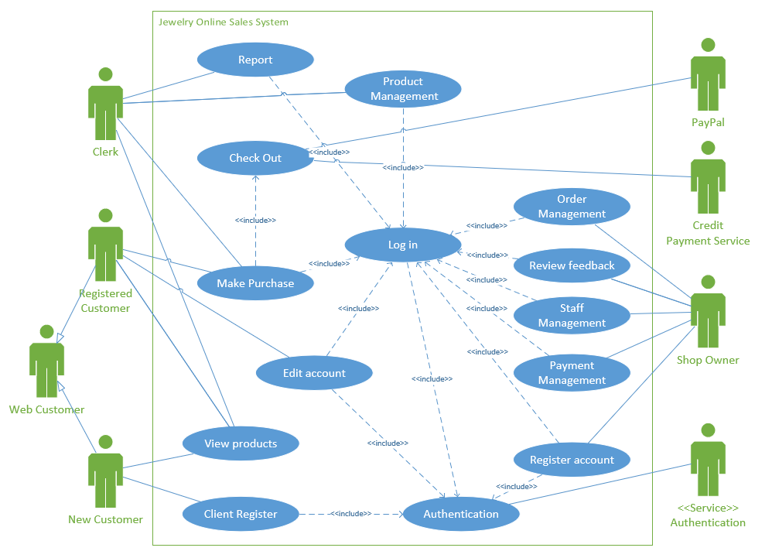

*Figure 1: Use case diagram for Jewelry online sales system*

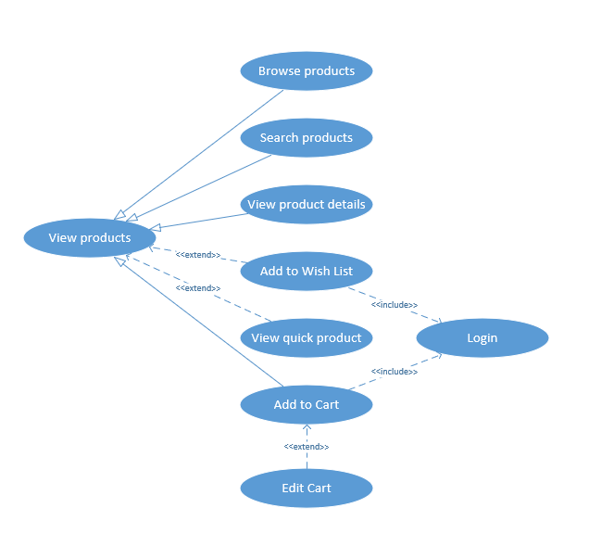

*Figure 2: Sub use case diagram for View products*

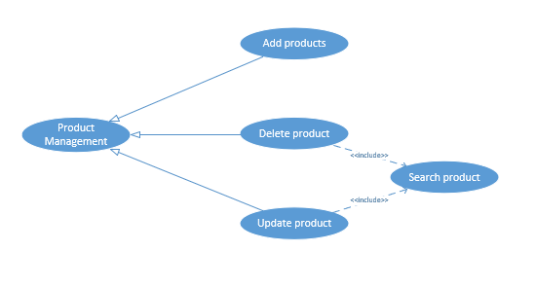

*Figure 3: Sub use case diagram for Product Management*

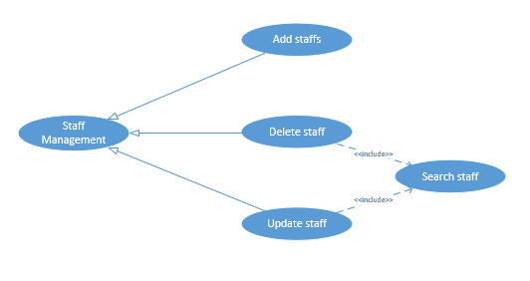

*Figure 4: Sub use case diagram for Staff Management*

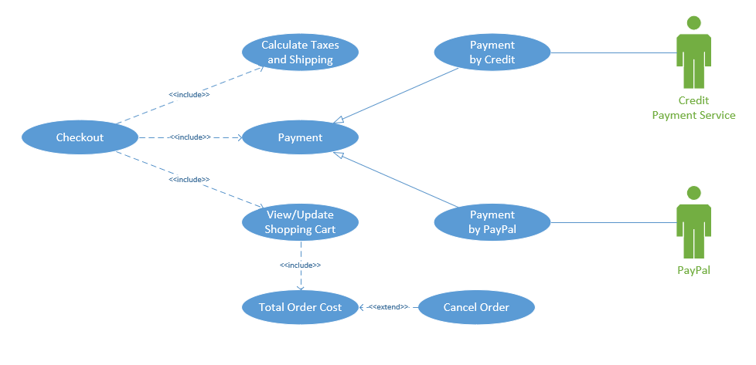

*Figure 5: Sub use case diagram for Checkout*

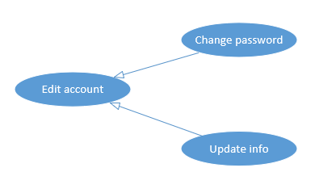

*Figure 6: Sub use case diagram for Edit account*

2.3 List of Use cases

There are 14 top level use cases: View products, Client Register, Edit account, Make Purchase, Checkout, Report, Product Management, Login, Authentication, Register account, Payment Management, Staff Management, Review feedback, Order Management.

* View products: this use case allows customers to find information view products.
* Browse products: this use case allows customers browse products
* Search products: this use case allows customers to find products they are looking for.
* View product details: this use case allows customers to view a product detail.
* Add to Wishlist: this use case allows customers to add products to their desired list
* View quick product: this use case allows customers quick view products
* Add to Cart: this use case allows customers to add products they like to the basket.
* Edit Cart: this use case allows customers view products, changes quantity, delete product in shopping cart.
* Client Register: this use case allows new customers register account.
* Edit account: this use case allows customer change their account password or update use their account information.
* Change password: this use case allows customers update their account password.
* Update info: this use case allows customers update user their account information.
* Make Purchase: this use case that mean customer purchase product.
* Checkout: this use case allows guests to view items in the basket before ordering.
* Calculate Taxes and Shipping: this use case alows the system calculated taxes and shipping of order.
* Payment: this user allows customer to pay by prepaid or postpaid service.
* Payment by Credit: this user allows customer to pay by credit card.
* Payment by PayPal: this user allows customer to pay by paypal.
* View/Update Shoppping Cart: this use case allows customer views products, changes quantity, delete product in shopping cart.
* Total Order Cost: this user allows the system to calculate and update the total number of products in the customer basket.
* Cancel Order: this use case allows customers cancel their order.
* Report: this use case allows clerk report what happened in the store and the transaction.
* Product Management: this use case allows clerk manages products on system.
* Add products: this use case allows Product Manager to add a new product.
* Delete product: this use case allows product manager to remove the product from the database on the system.
* Search product: this use case allows the product manager to search product from the information they provide themselves.
* Update product: this use case allows the product manager to change product information.
* Search product: this use case allows the product manager to search product from the information they provide themselves
* Login: this use case allows user login into their account.
* Authentication: this use case allows the system to verify the identity of the customer.
* Register account: this use case allows Admin register account for staff
* Payment Management: this use case allows Admin manage all payment of customers.
* Staff Management: this use case that mean admin manage staffs.
* Add staffs: this use case allows admin to add a new staff.
* Delete staff: this use case allows admin to remove the staff from the database on the system.
* Search staff: this use case admin to search staff from the information they provide themselves.
* Update staff: this use case allows admin to change staff information.
* Search staff: this use case admin to search staff from the information they provide themselves.
* Review feedback: this use case allows admin review report of clerk
* Order Management: this use case allows admin manage orders of all customers.

2.4 Use case detailed description

2.4.1 Use case UC100 View products

**Description:** This use case describes how the users can search and view products.

**Primary Actor**: Web customer and Clerk

**Priority:** Must have

**Trigger:** None

**Pre-Conditions**: Users opened the web.

**Post-Conditions:** Customers or Clerk find and view products.

**Flow of Events**:

**Basic Flows**:

1.User opens a web browser, gives the URL and clicks on ‘Enter’ button.

2. System launches the web site.

3. User enters text in text box next to Search button and clicks on Search button.

4. System displays the matching text products.

5. User clicks on the desired link. User can navigate back to the earlier pages if wishes.

**Alternate Flow**:

3a. If search returns no results, System displays the message “No matches found for the entered text”.

**Exception Flow**: System displays the error messages.

2.4.2 Use case UC200 Client Register

**Description:** This use case describes how the users can search and view products

**Primary Actor:** New Customer

**Priority:** Should have

**Trigger:** Users click on “Register’ button

**Pre-Conditions**: Users opened the web.

**Post-Conditions:** User register new account

**Flow of Events**:

**Basic Flows**:

1. The use case are started when user clicked on register button

2. System show register form

3. User fill all information in form

4. System check username is already exists

5. System check password to meet condition

6. System display message “Sign Up Success”

**Alternate Flow**:

4a. If username is already exists, display message “Username is already exits, please re-enter other username”

5a. If password doesn’t meet condition, display message “Password has at least 8 characters and includes letters and numbers

**Exception Flow**: System displays the error messages

2.4.3 Use case UC300 Edit account

**Description:** This use case describes how the users can edit account information edit the account information except the username

**Primary Actor**: Customer, Clerk

**Priority:** Could have

**Trigger:** User click on “Edit Account” button

**Pre-Conditions**: User opened “Manage my account” site, user must login

**Post-Conditions:** User edit account information

**Flow of Events**:

**Basic Flows**:

1. The use case started when user click on edit “Edit” button

2. User click on change button

3. System check each information that user changed

4. User confirm to change information

5. …

**Alternate Flow**:

3a. If that is password, system send the confirm form to user email and display message “Please check email and click on link in there if you confirm information is correct”.

3b. If that is email, system send the confirm form to user email and display message “Please check email and click on link in there if you confirm information is correct”.

3c. If that is other information, system display confirm form in site.

4a. User click on link confirm in their email.

4b. User click on button confirm in confirm form is displayed in site

**Exception Flow**: System displays the error messages

2.4.4 Use case UC400 Make Purchase

**Description:** This use case describes how the users can make purchase or add product to their cart

**Primary Actor**: Customer, Clerk

**Priority:** Must have

**Trigger:** users has added product into cart

**Pre-Conditions**: The website is opened, user must login and cart contained product

**Post-Conditions:** User choose product that they need.

**Flow of Events**:

**Basic Flows**:

1. The use case started when user click on “add to cart” button

2. System check product that is chosen by user is available

3. System display animation to move product’s icon on cart’s icon.

**Alternate Flow**:

2a. If product is not available in the stock, display message “This product are sold out”

**Exception Flow**: System displays the error messages

2.4.5 Use case UC500 Checkout

**Description:** This use case describe how user check out after make purchase

**Primary Actor**: Customer, Clerk

**Priority:** Must have

**Trigger:** When users added products to cart and click on “checkout” button

**Pre-Conditions**: User must make purchase with least one product, user must login

**Post-Conditions:** User want to checkout

**Flow of Events**:

**Basic Flows**:

1. The use case started when user move on their cart and click on “Checkout” button

2. Display total amounts and all products that user add to their cart

3. User check quantity of each product, they can change it

4. System check quantity of each product

5. User click on “Confirm” button to confirm information of bill and address(shipping)

6. Display message “Checkout is success”

**Alternate Flow**:

4a. If quantity of each product is changed, update total amounts and quantity

**Exception Flow**: System displays the error messages

2.4.6 Use case UC600 Report

**Description:**  This use case describes how to user can export the report

**Primary Actor**: Clerk

**Priority:** Should have

**Trigger:** when Clerk click on “Report” button

**Pre-Conditions**: User must stay on the Manage store site, user must login

**Post-Conditions:** User want export the report of all bill

**Flow of Events**:

**Basic Flows**:

1. The use case is started when use click on export button

2. System displays information of report in screen (default is daily report)

3. User changes the type of report to export

4. The system checks the type of report to export

5. Export pdf file of report and display message “Success”

**Alternate Flow**:

4a. If the report type to export is monthly, update the information on the screen

4b. If the report type to export is quarterly, update the information on the screen

4c. If the report type to export is yearly, update the information on the screen

**Exception Flow**: System displays the error messages

2.4.7 Use case UC700 Product Management

**Description:** This use case describes how user can manage the product

**Primary Actor**: Clerk

**Priority:** Must have

**Trigger:** When users go to dashboard page

**Pre-Conditions**: User must stay on the Manage store site, user must login

**Post-Conditions:** User want update of add new product to store

**Flow of Events**:

**Basic Flows**:

1. This use case is started when use click on manage button.

2. User choose management option by click on add, delete, edit product button

3. System check option that user chose.

4. Display change confirm form.

5. User confirm in form.

**Alternate Flow**:

3a. If user choose add option, start add use case

3b. If user choose delete option, delete add use case

3b. If user choose edit option, delete add use case

**Exception Flow**: System displays the error messages

2.4.8 Use case UC800 Login

**Description:** This use case describe how to user can login to website

**Primary Actor**: Customer, Clerk, Shop owner

**Priority:** Should have

**Trigger:** When users click on “Login” button

**Pre-Conditions**: The website is opened

**Post-Conditions:** User login to use any function in website

**Flow of Events**:

**Basic Flows**:

1. The use case are stated when user click login button or use more other use case as make purchase, checkout, report, ….

2. System display login form

3. User enter username and password into login form

4. System check username and password are valid

5. User click on login button

5. Display the previous screen

**Alternate Flow**:

4a. If information is valid, display message “Successfully”

4b. If information is invalid, display message “Username or password is incorrect, Please re-enter once”

**Exception Flow**: System displays the error messages

2.4.9 Use case UC900 Register account

**Description:** The use case describer how to create new account for Clerk

**Primary Actor**: Shop Owner

**Priority:** Must have

**Trigger:** When Shop owner click on “Create new account” in dashboard page

**Pre-Conditions**: Website is opened, user must login successfully

**Post-Conditions:** User want create new account for clerk

**Flow of Events**:

**Basic Flows**:

1. The use case is started when user click on button create clerk account

2. System show register form.

3. User enter all information that form required

4. System check username is already exists

5. System check password to meet condition

6. User click on register button

7. Display message “ register successfully”

**Alternate Flow**:

4a. If username is already exist, display message “Username is already exits, please re-enter other username”

5a. If password doesn’t meet condition, display message “Password has at least 8 characters and includes letters and numbers

**Exception Flow**: System displays the error messages

2.4.10 Use case UC1200 Staff Management

**Description:** This use case describer how to edit, delete clerk account

**Primary Actor**: Shop Owner

**Priority:** Must have

**Trigger:** When Shop owner go to dashboard page

**Pre-Conditions**: Website is open, user must login

**Post-Conditions:** User want to edit or delete clerk account

**Flow of Events**:

**Basic Flows**:

1. The use case is started when user lick on button staff manage

2. Display staff manage screen

3. User choose manage option in manage screen

4. System check the option that user chose

5. System display confirm form

6. User click on confirm button

7. System display message “Change will be apply”

**Alternate Flow**:

4a. If user choose edit option, system will implement staff account edit use case

4b. If user choose delete option, system will implement staff account delete use case

Exception Flow: System displays the error messages

2.5 Collaboration Diagram

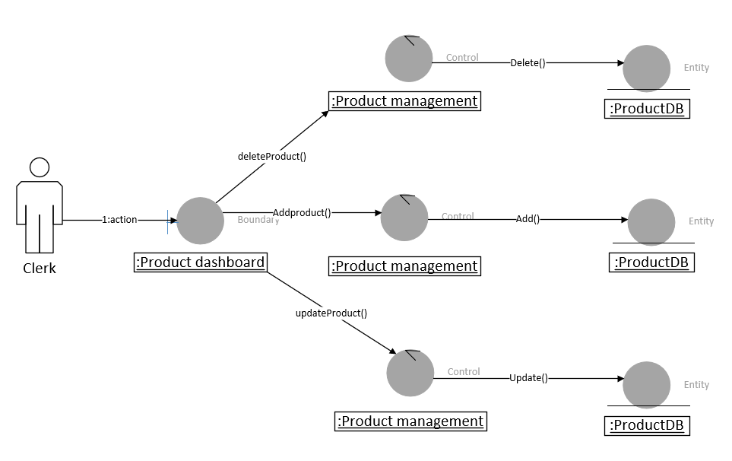

*Figure 7: Collaboration diagram for product management*

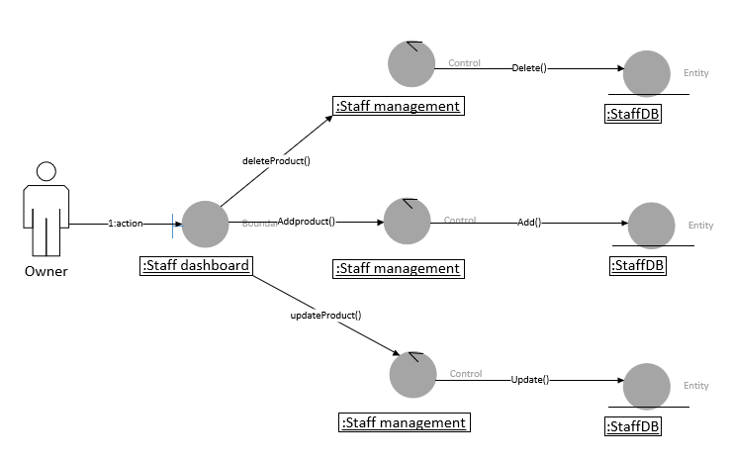

*Figure 8: Collaboration diagram for staff management*

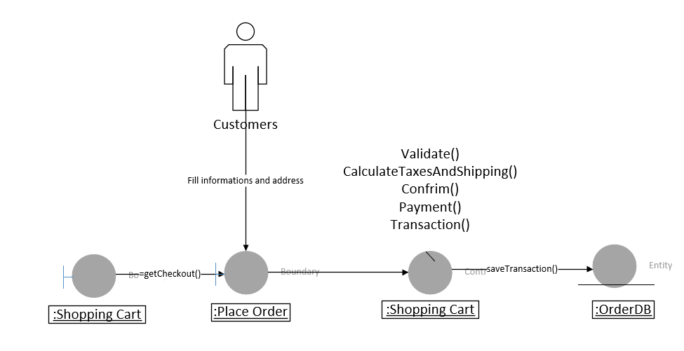

*Figure 9: Collaboration diagram for purchase*

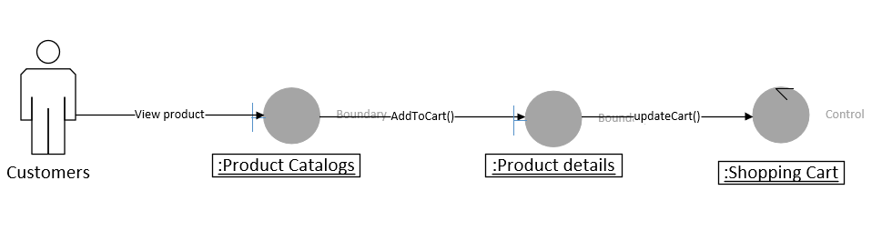

*Figure 10: Collaboration diagram add to shopping cart*

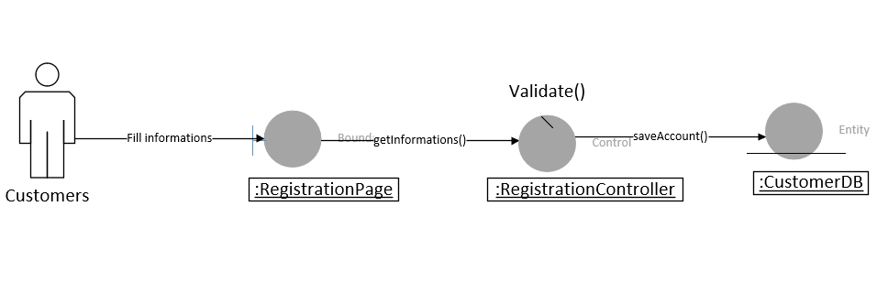

*Figure 11: Collaboration diagram for registration*

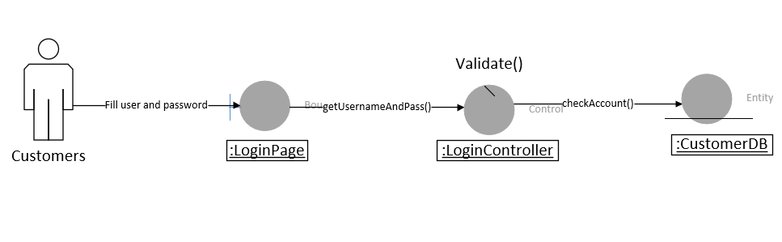

*Figure 12: Collaboration diagram for login*

2.5 Sequence Diagram

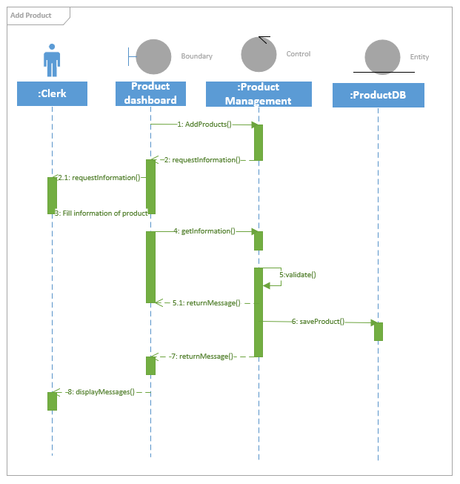

*Figure 7: Sequence diagram for add product*

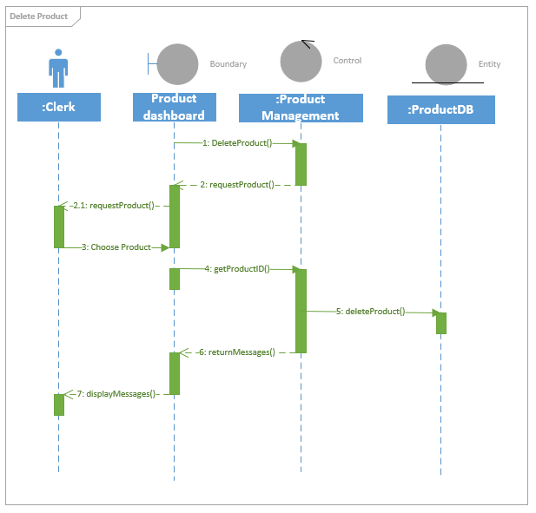

*Figure 8: Sequence diagram for delete product*

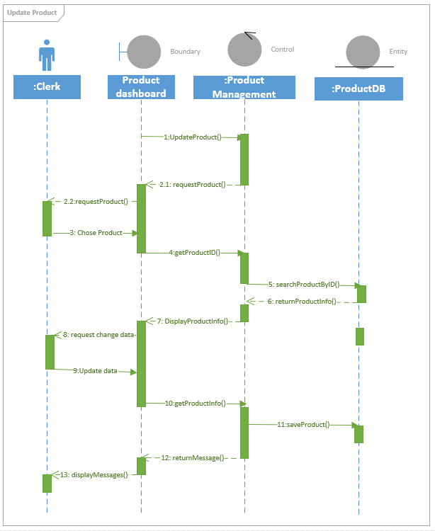

*Figure 9: Sequence diagram for update product*

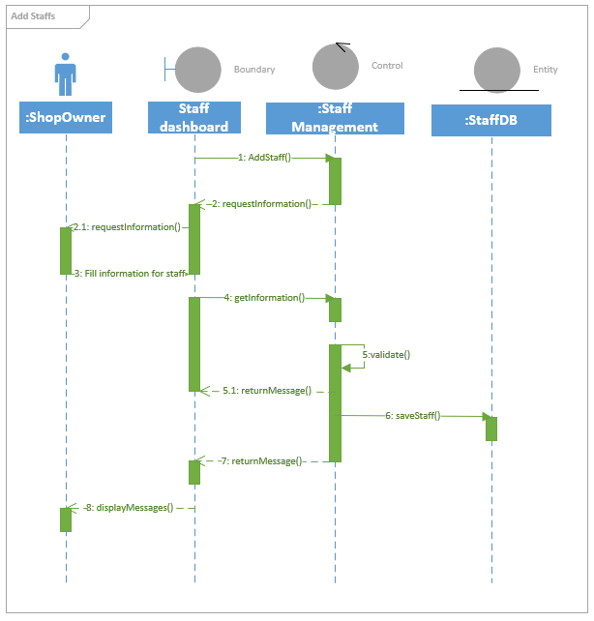

*Figure 10: Sequence diagram for add staff*

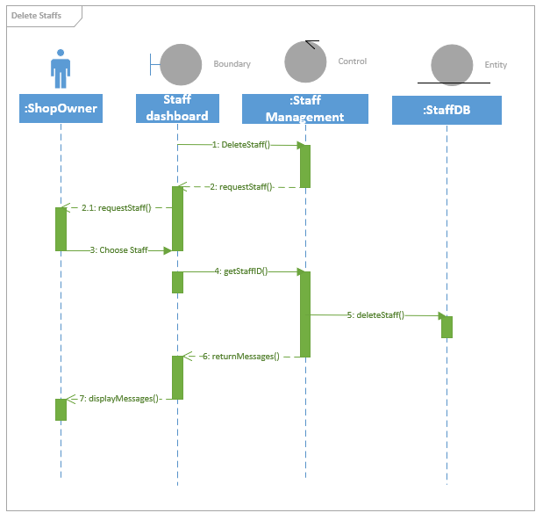

*Figure 11: Sequence diagram for delete staff*

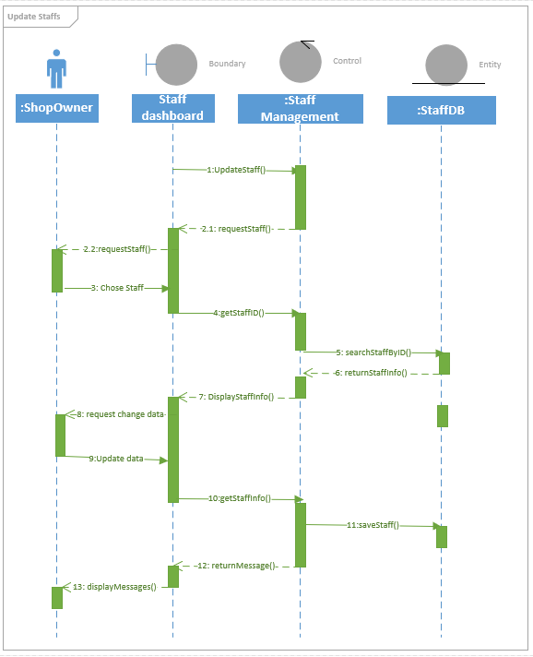

*Figure 12: Sequence diagram for update staff*

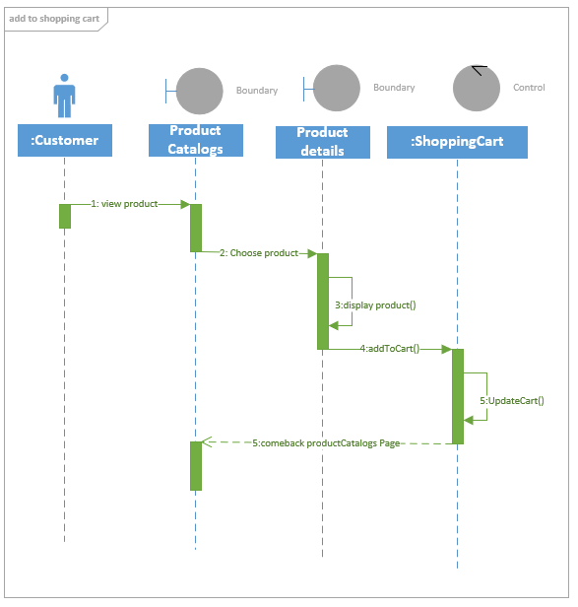

*Figure 13: Sequence diagram for add to shopping cart*

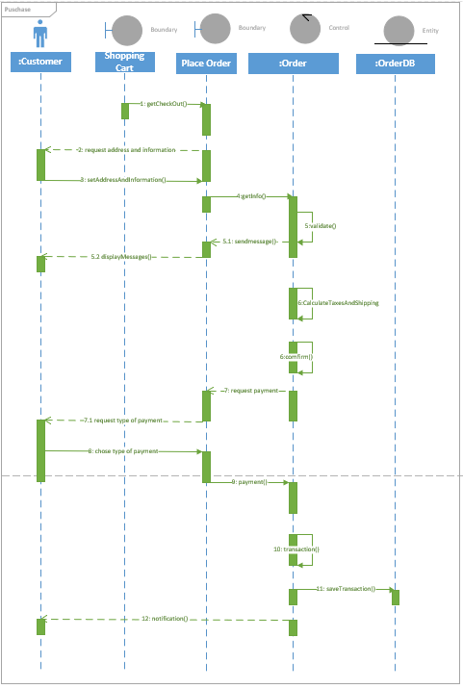

*Figure 14: Sequence diagram for purchase*

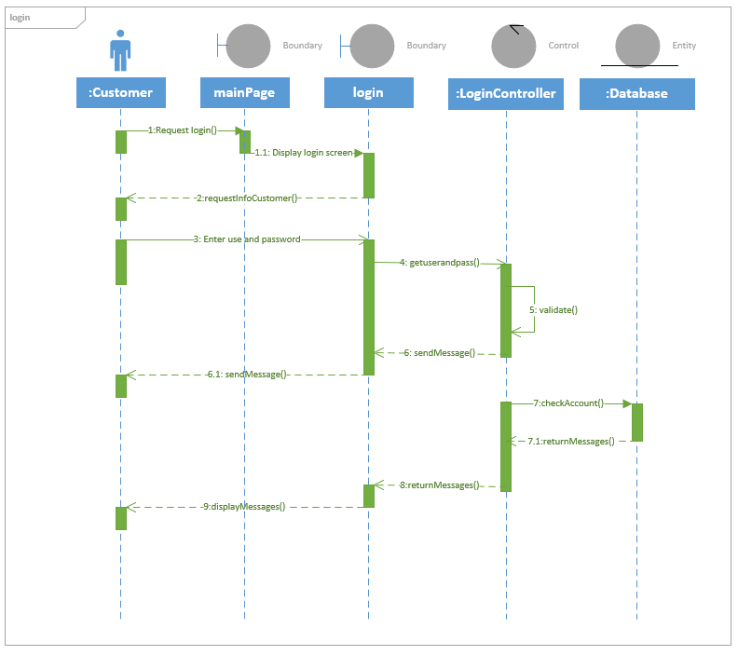

*Figure 15: Sequence diagram for login*

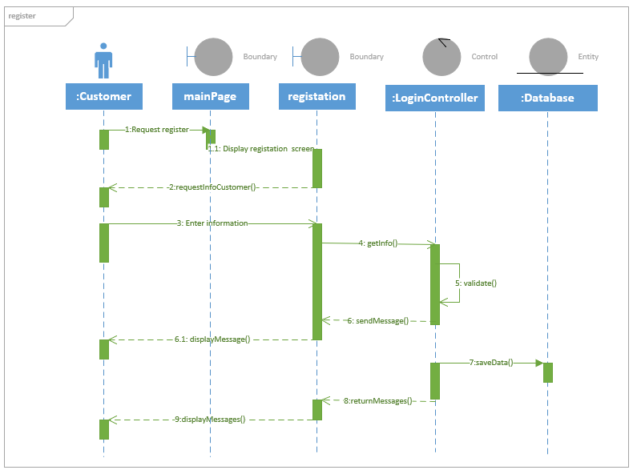

*Figure 16: Sequence diagram for registration*

2.6 Activity diagram

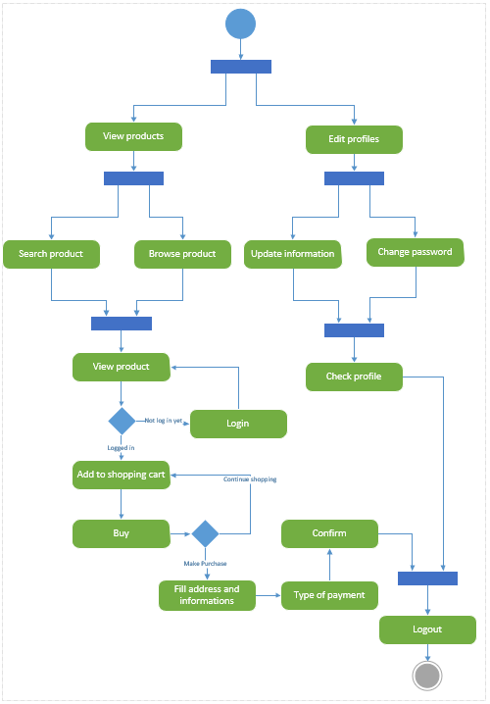

*Figure 17: Activity diagram for customer*

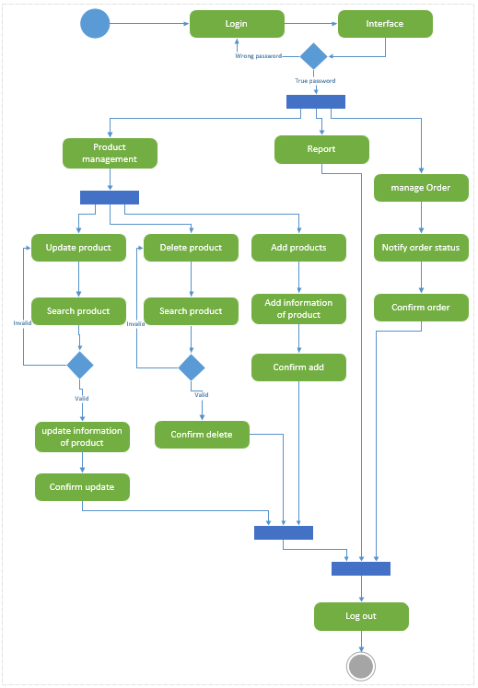

*Figure 18: Activity diagram for clerk*

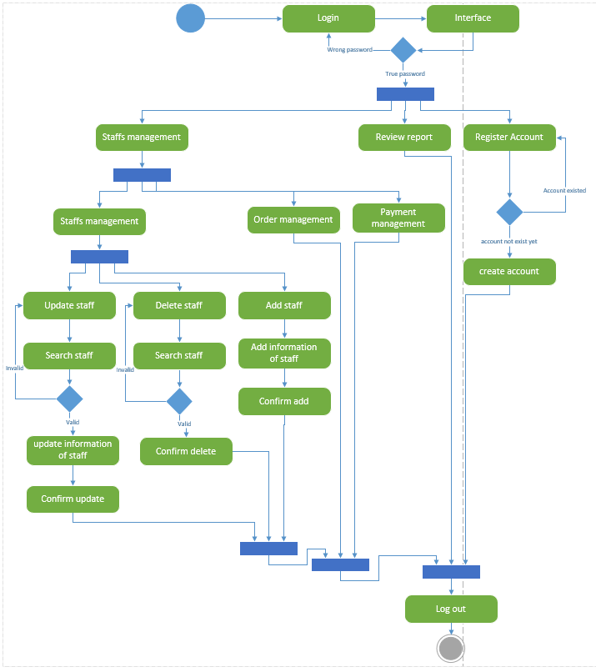

*Figure 19: Activity diagram for Shop Owner*

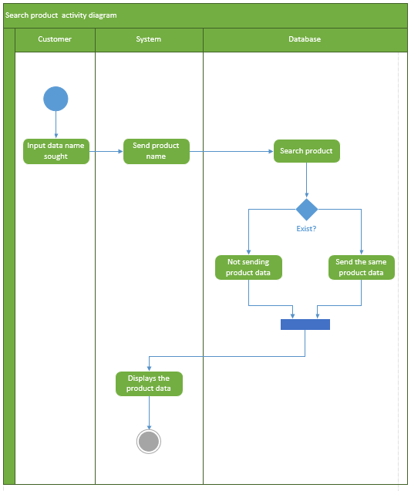

*Figure 20: Activity diagram for search product*

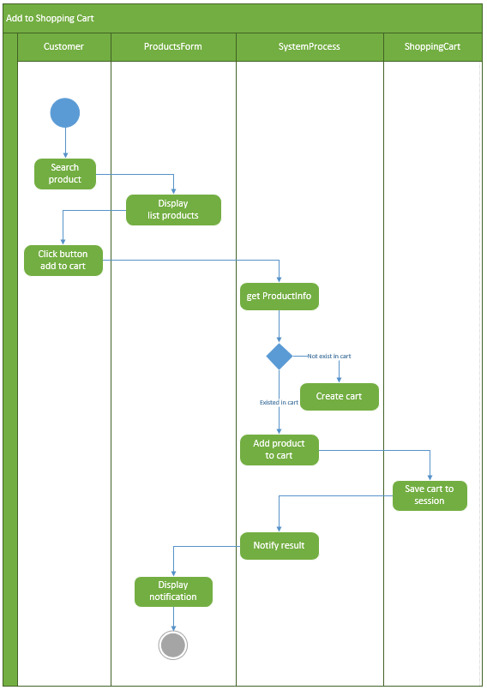

*Figure 21: Activity diagram for add to shoppping cart*

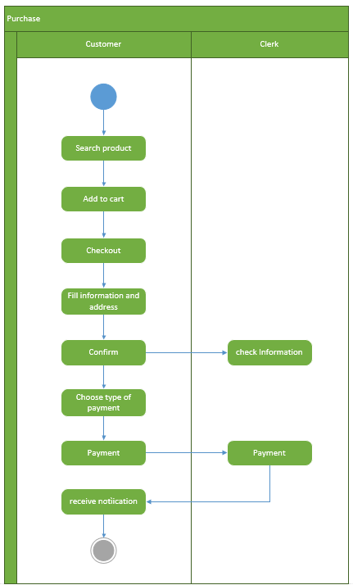

*Figure 22: Activity diagram for purchase*

2.7 Class Diagram

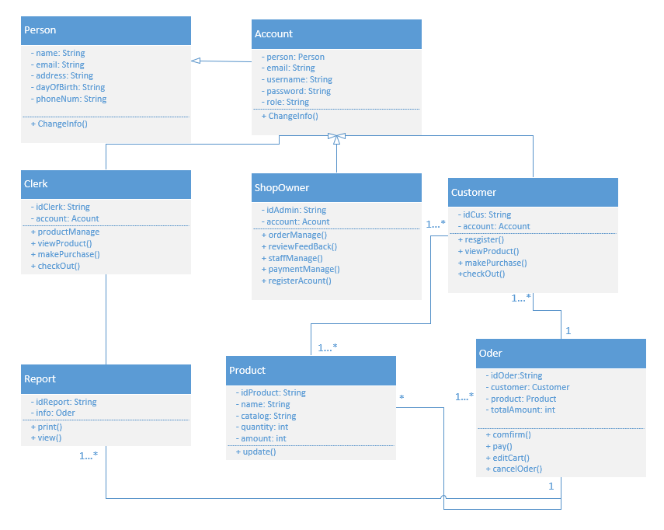

*Figure 23: Class diagram for Jewelry Online Shopping*

CHAPTER 3 – UI DESIGN

3.1 Blog pages

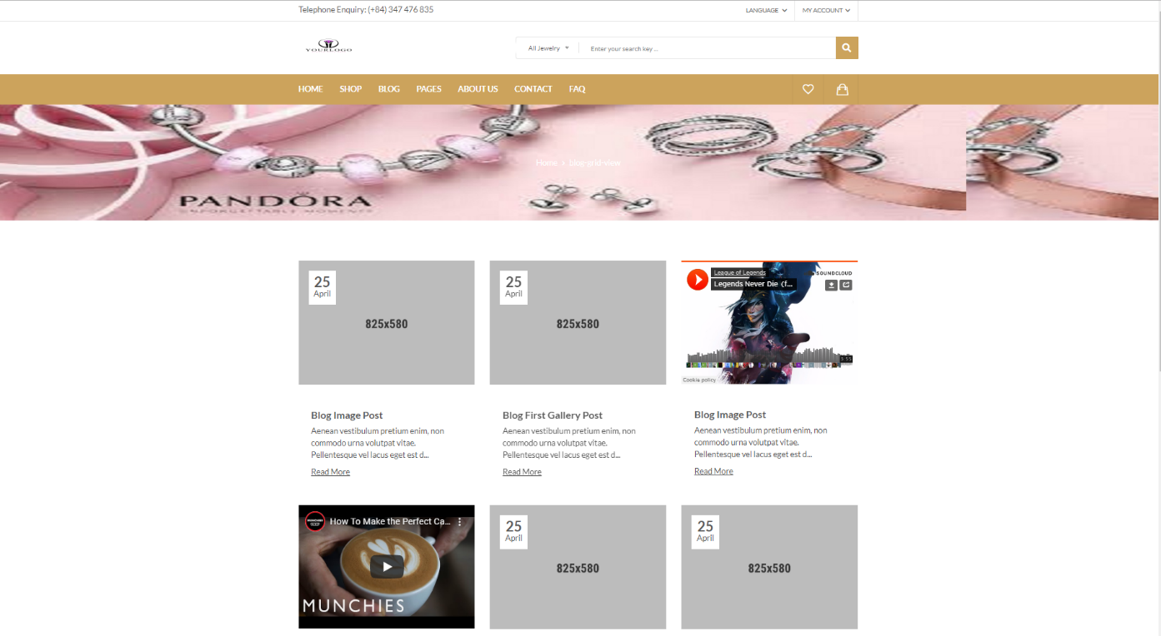

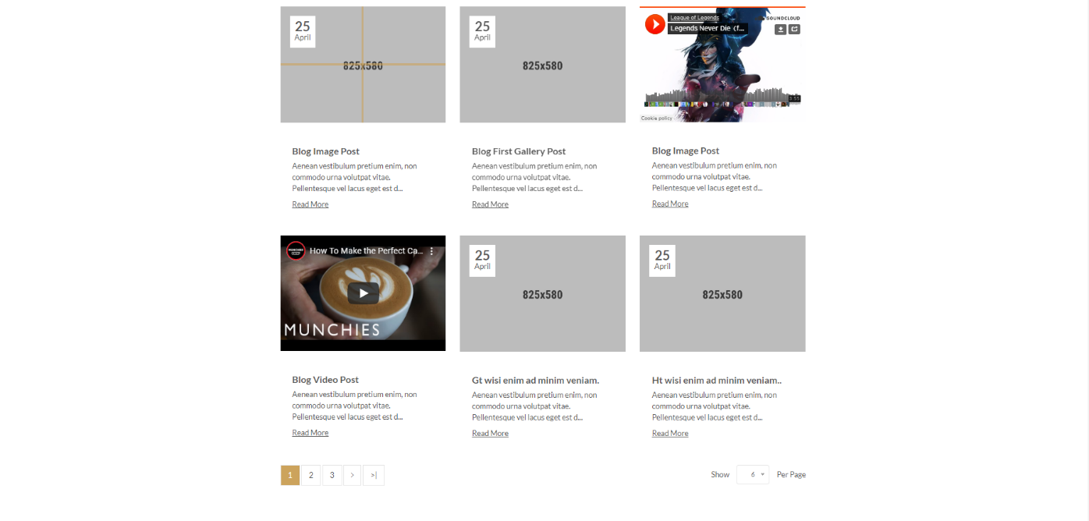

*Figure 24: UI of Blog Grid View page*

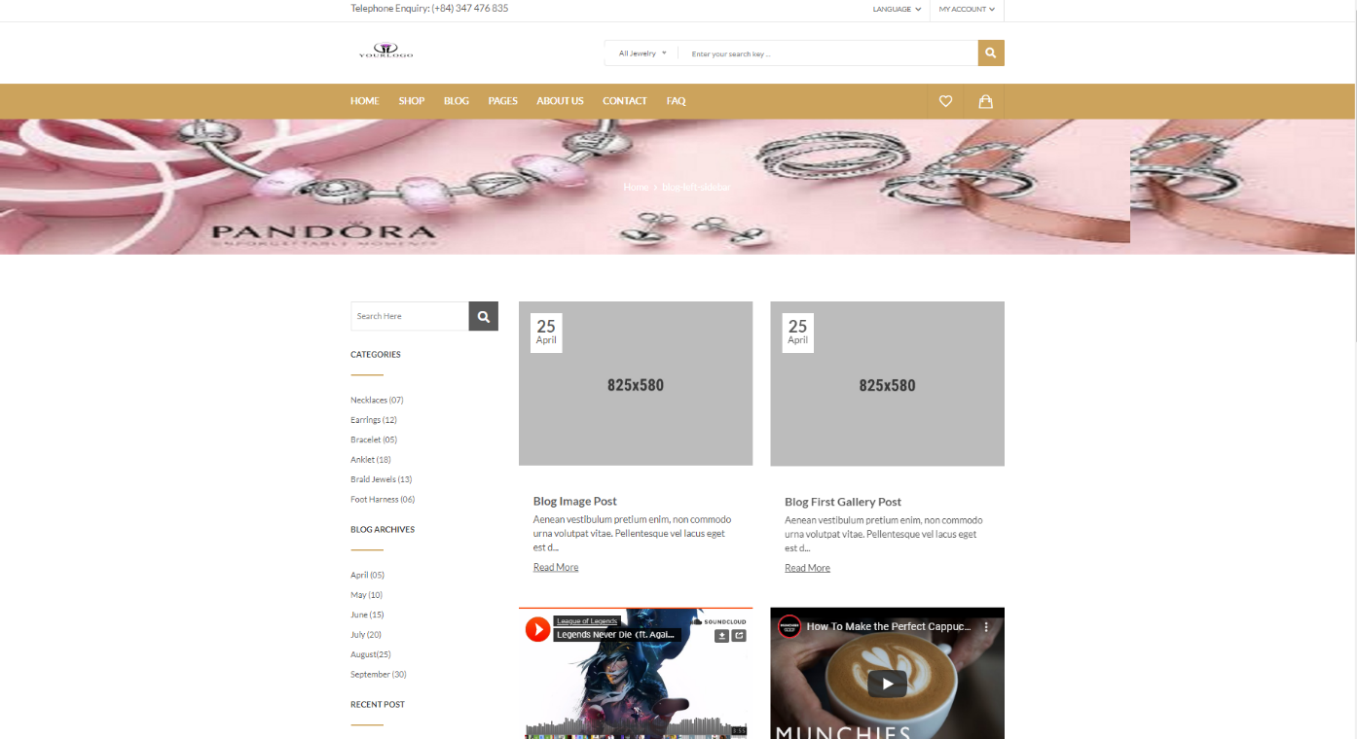

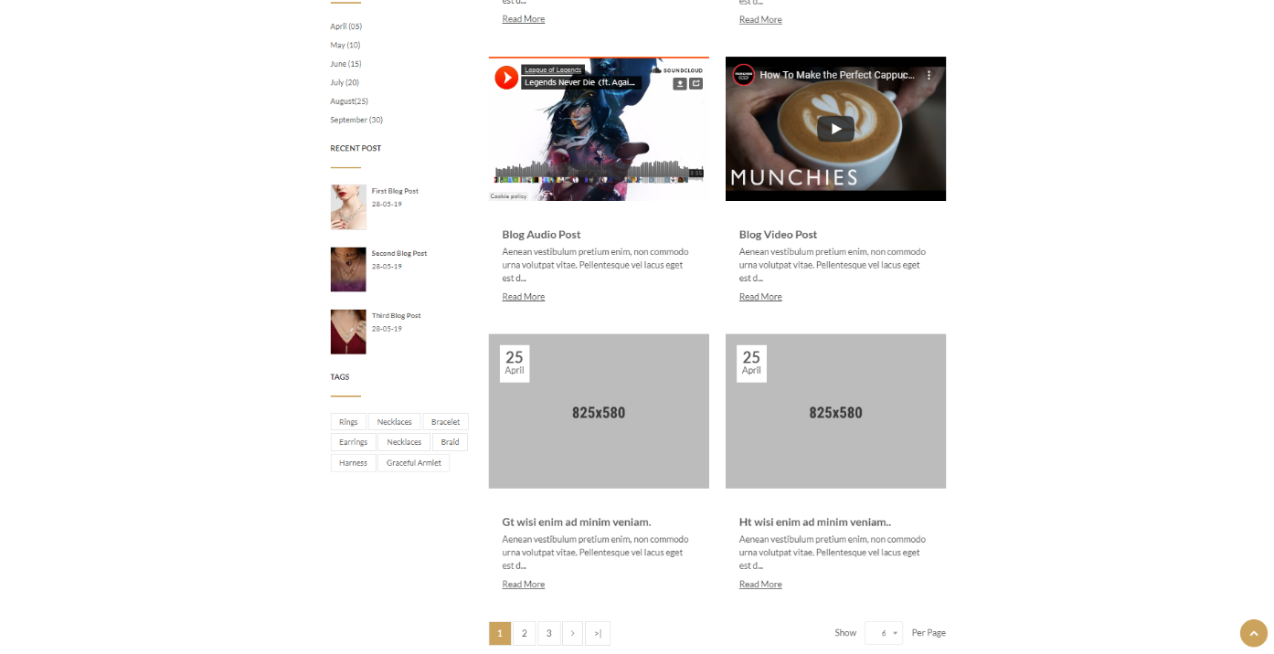

*Figure 25: UI of Blog Left Sidebar page*

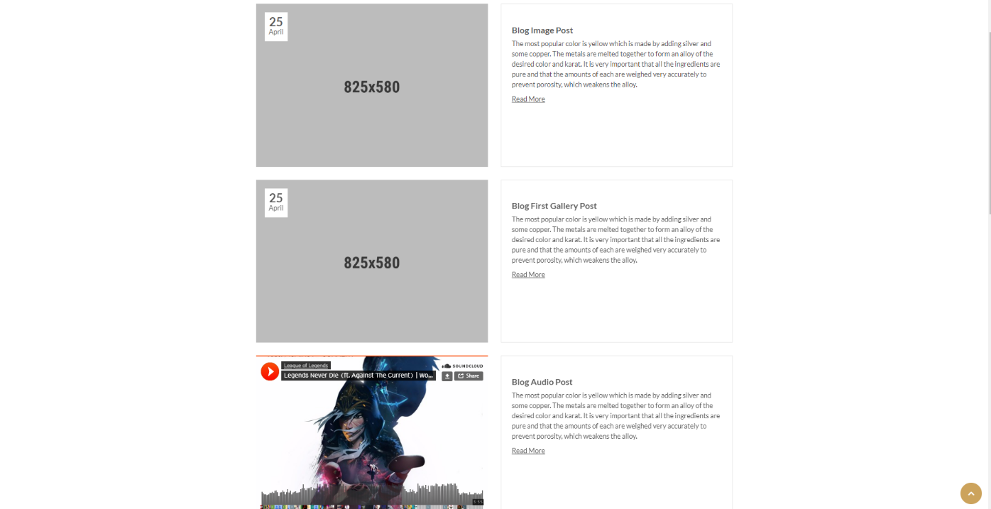

*Figure 26: UI of Blog List View page*

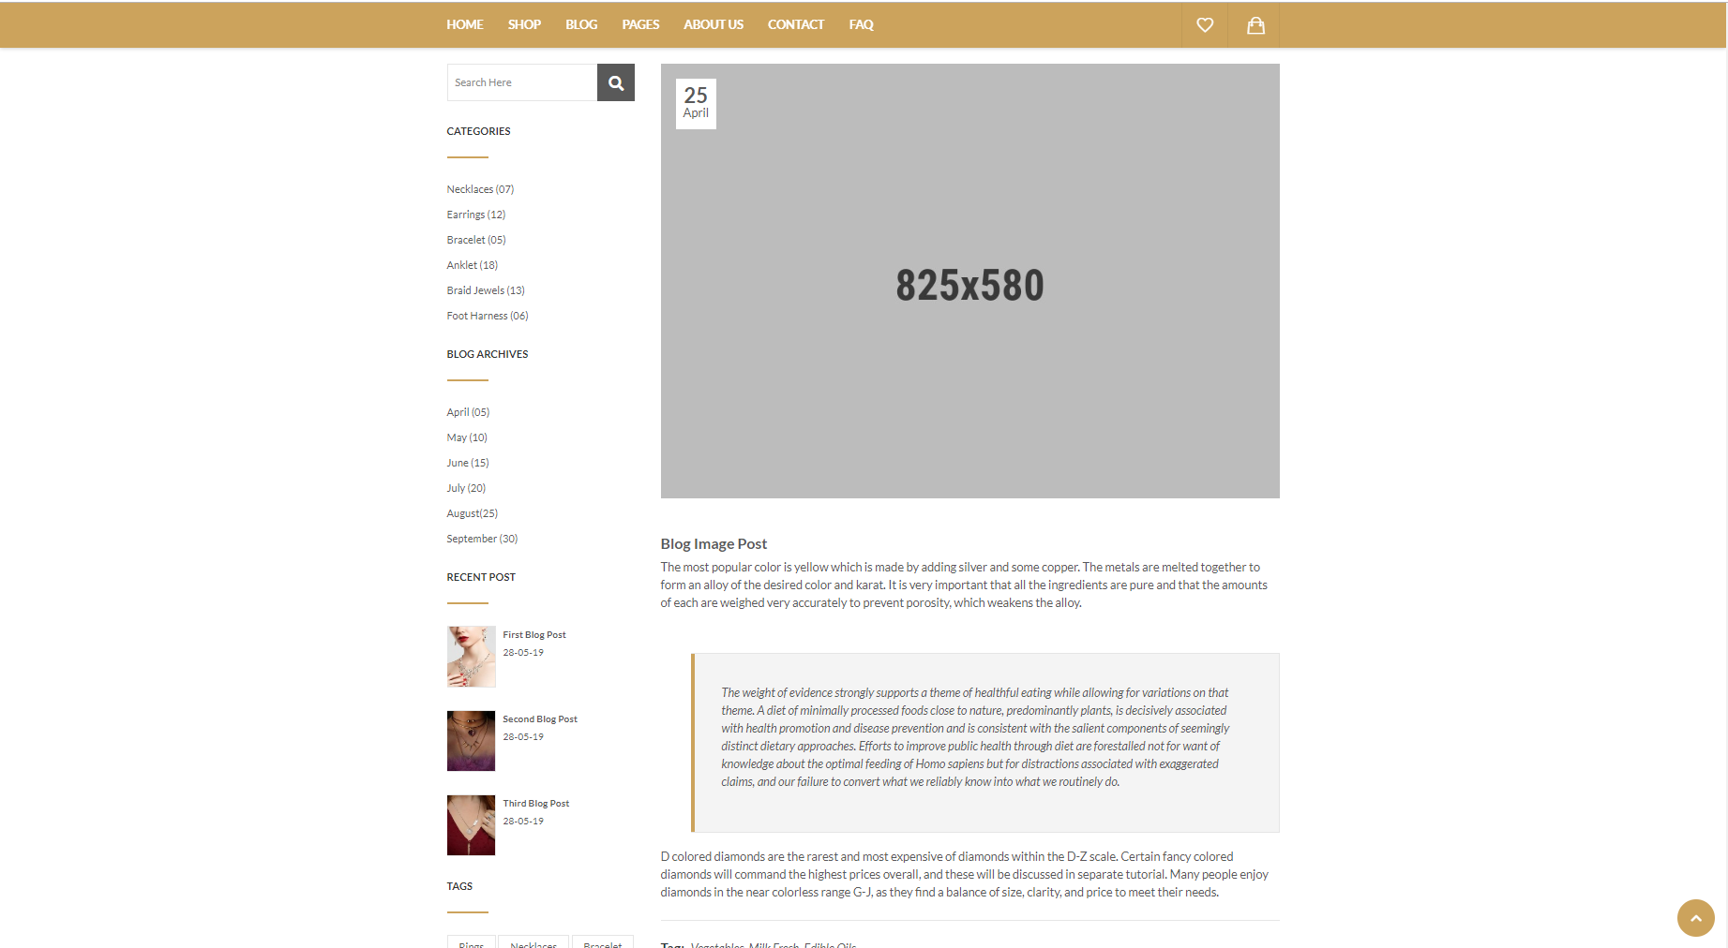

*Figure 27: UI of Details Blog page*

3.2 Shop pages

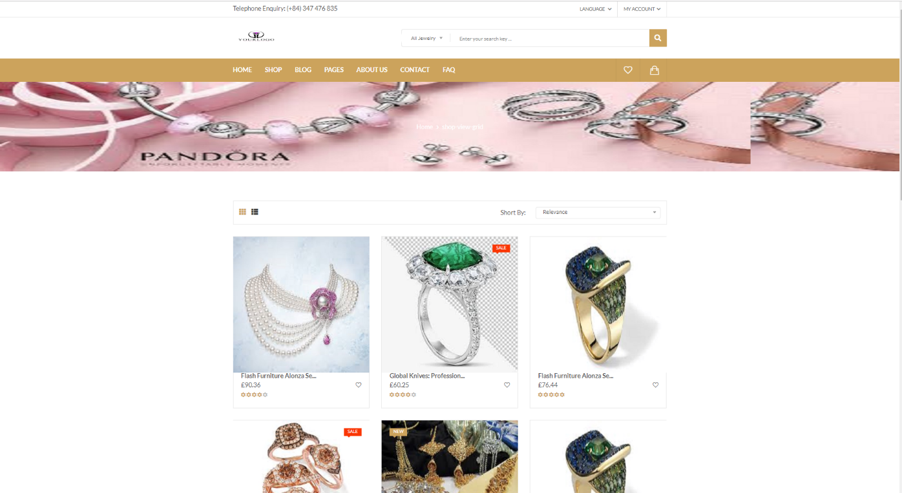

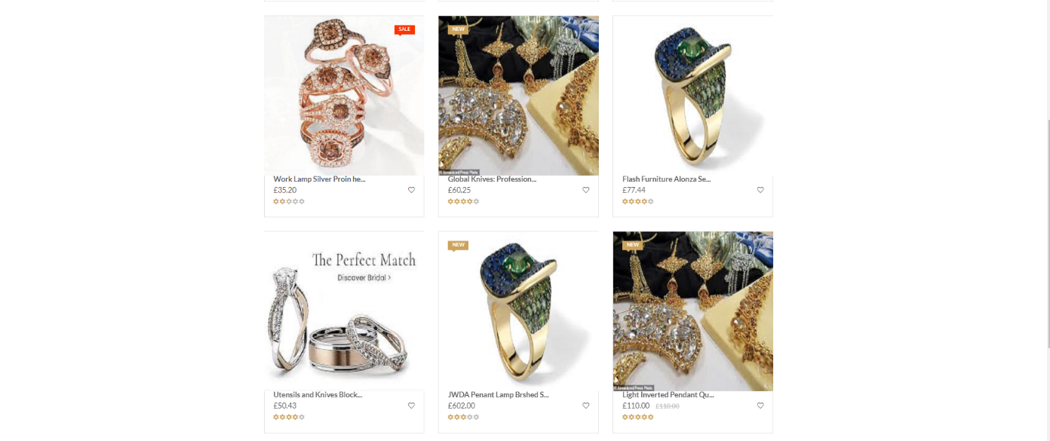

*Figure 28: UI of Shop Grid View page*

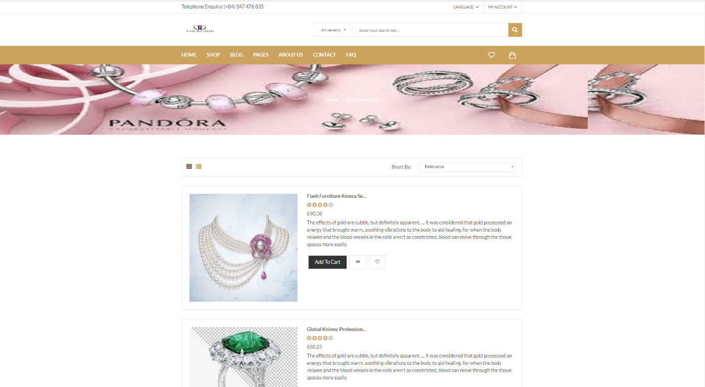

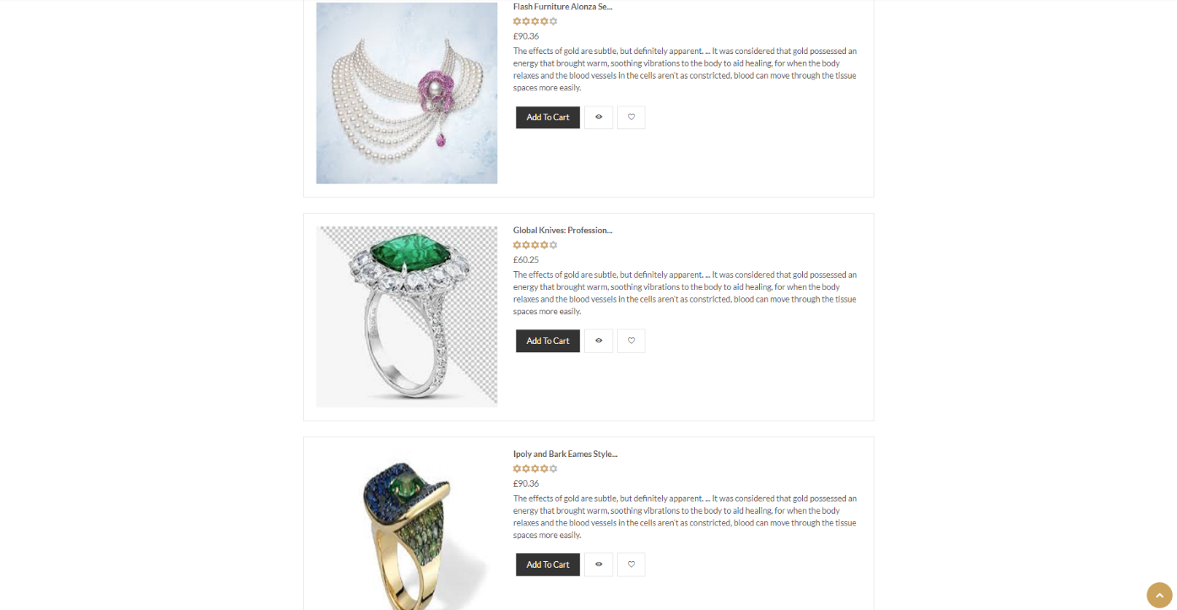

*Figure 29: UI of Shop List View page*

3.3 About us page

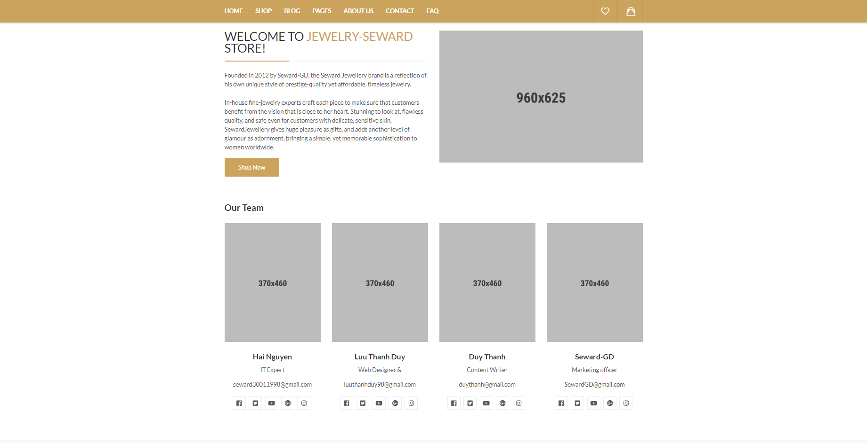

*Figure 30: UI of About Us page*

3.4 Contact page

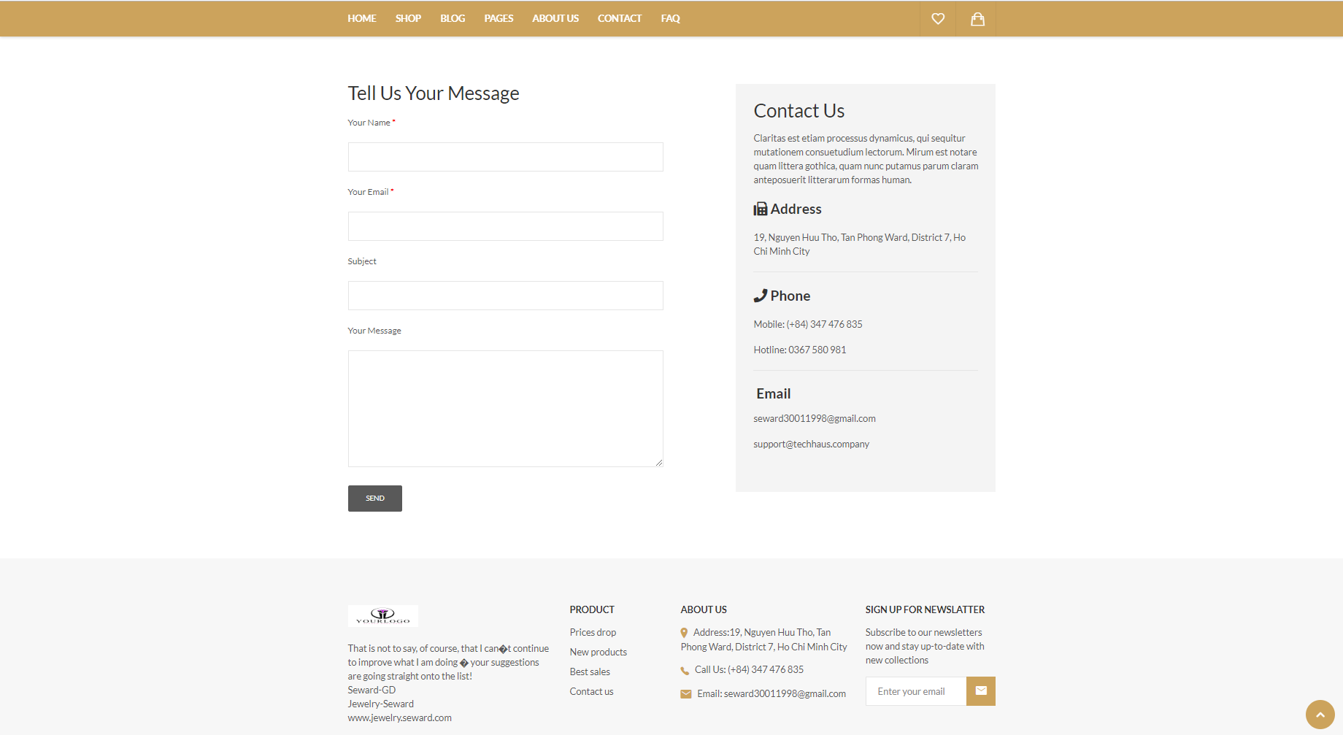

*Figure 31: UI of Contact page*

3.5 Faq page

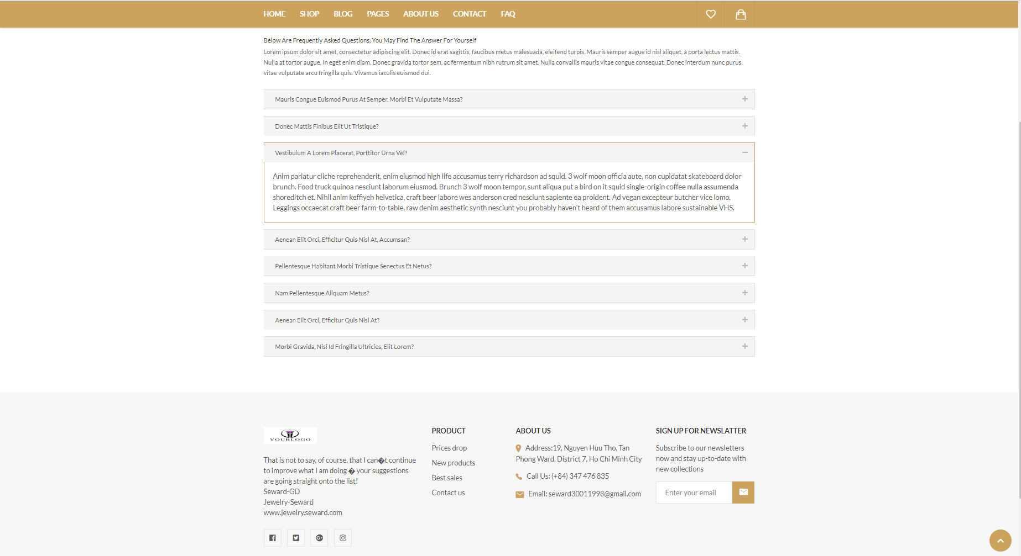

*Figure 32: UI of FAQ page*

3.6 Product details pages

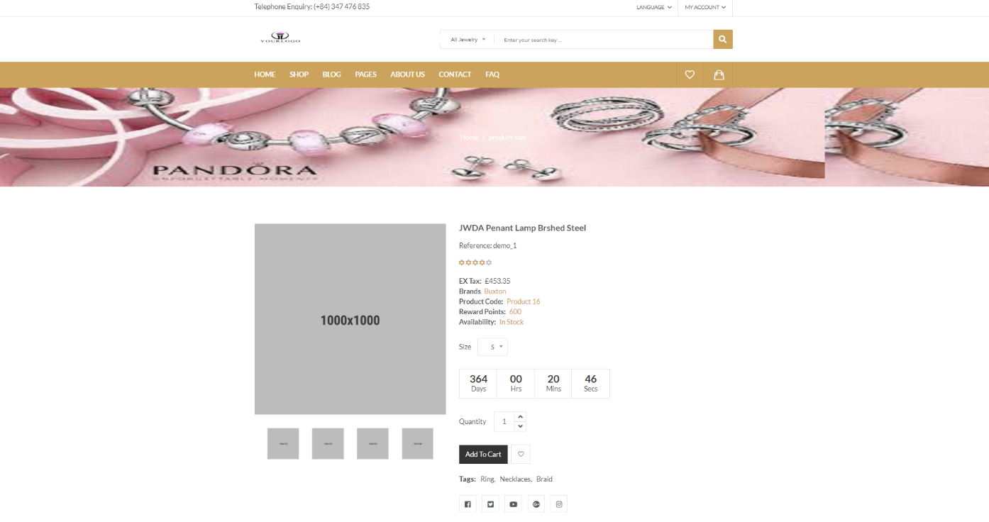

*Figure 33: UI of Sale Product details page*

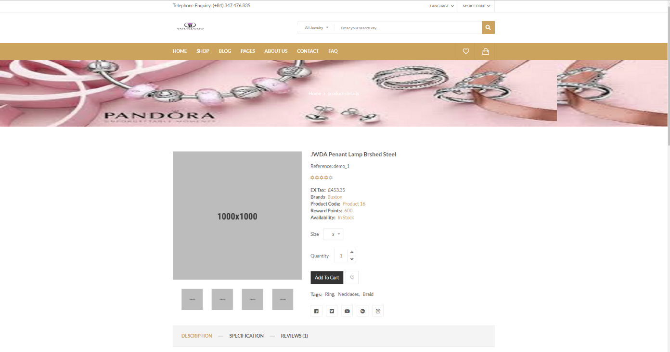

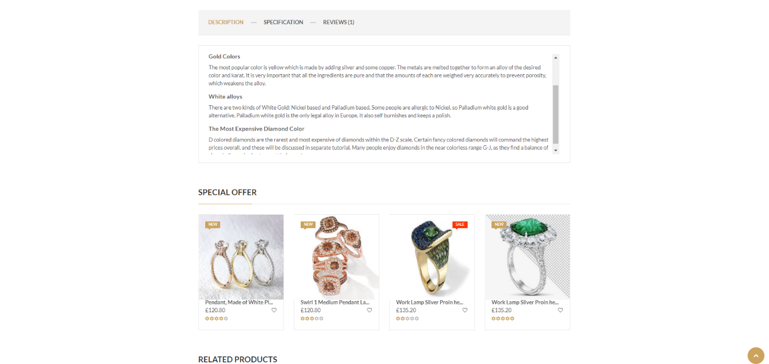

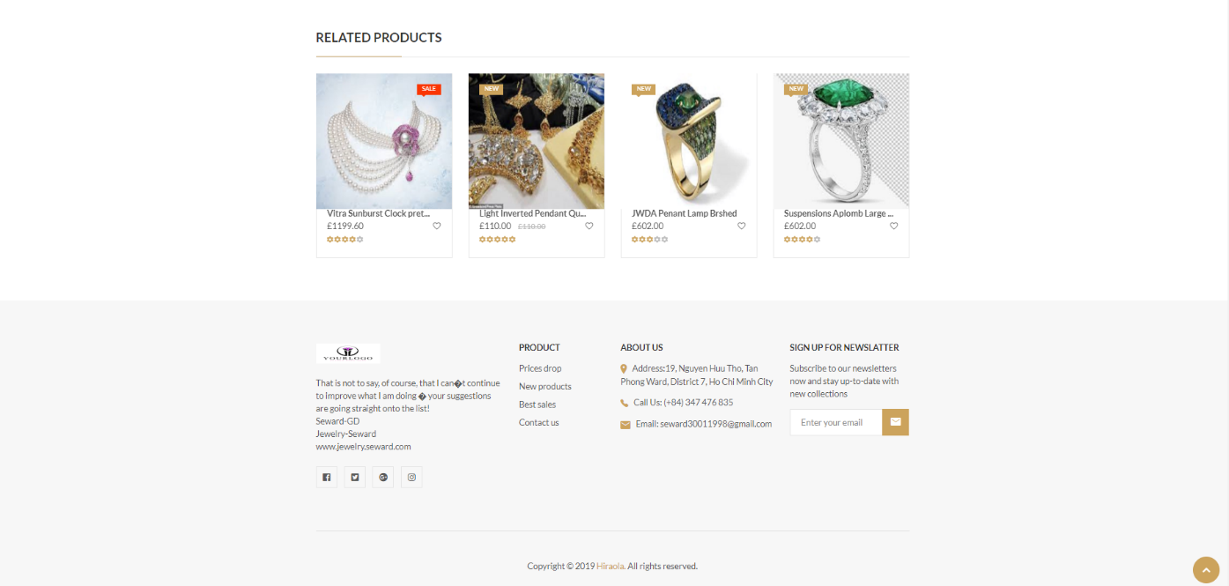

*Figure 34: UI of Product details page*

3.7 Shopping cart page

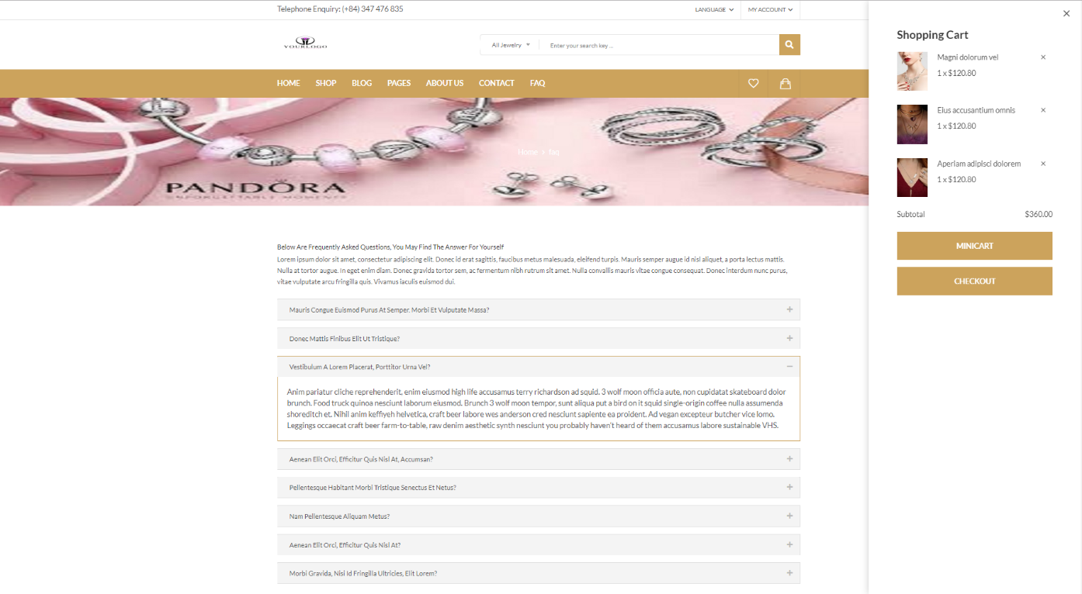

*Figure 35: UI of Cart*

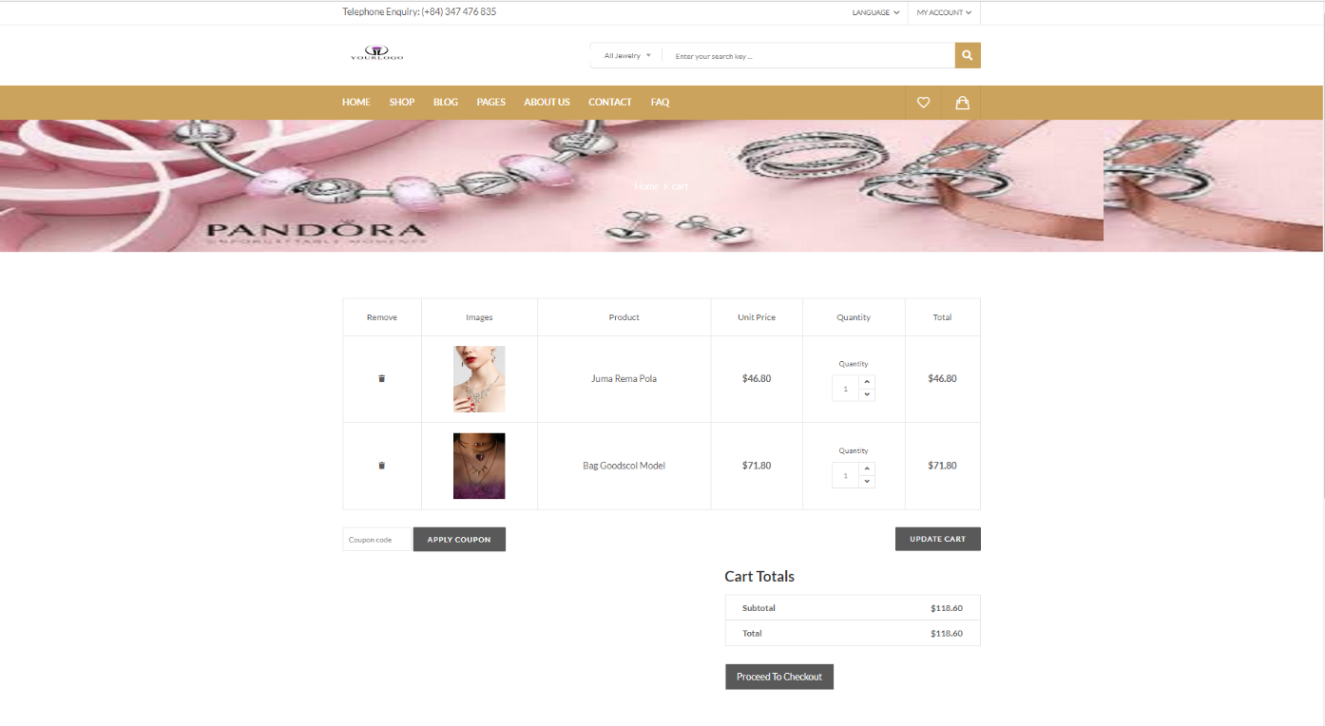

*Figure 36: UI of Cart page*

3.8 Checkout pages

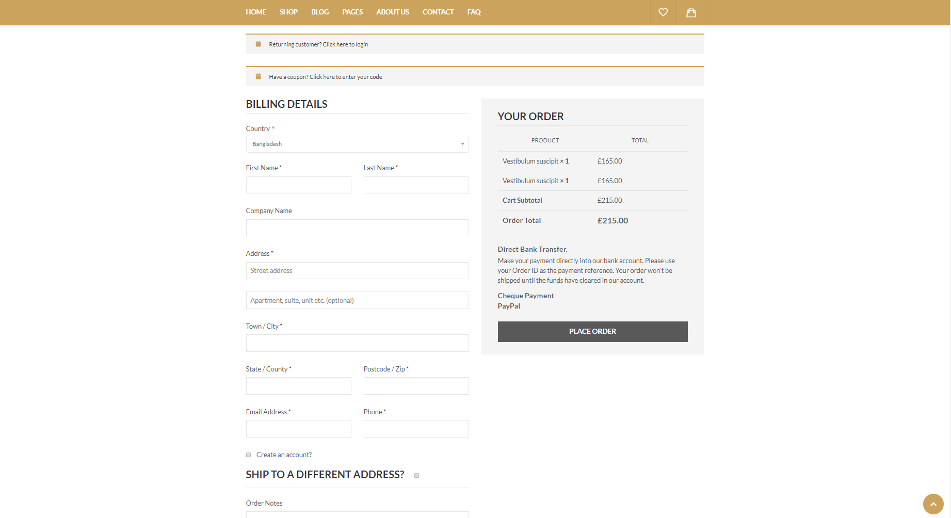

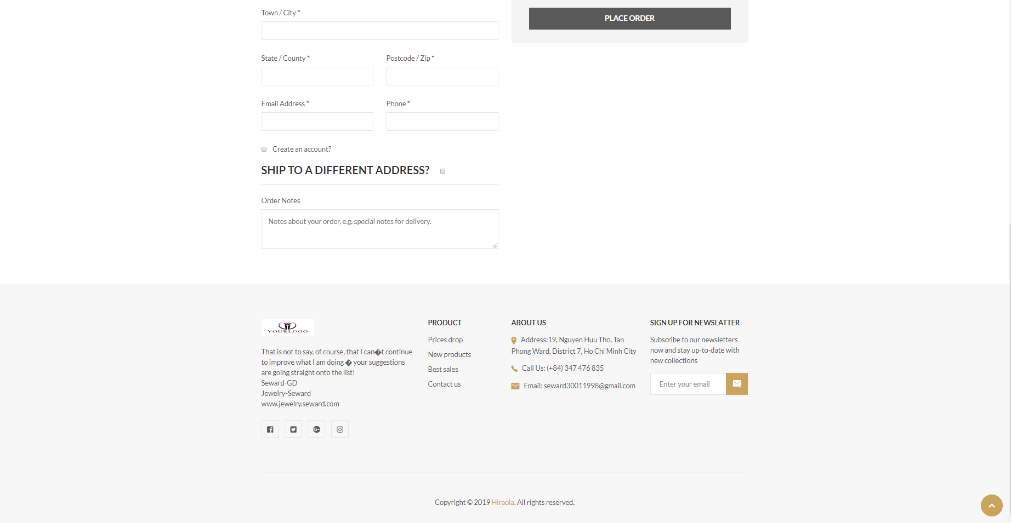

*Figure 37: UI of Checkout page*

3.9 Login and Registration page

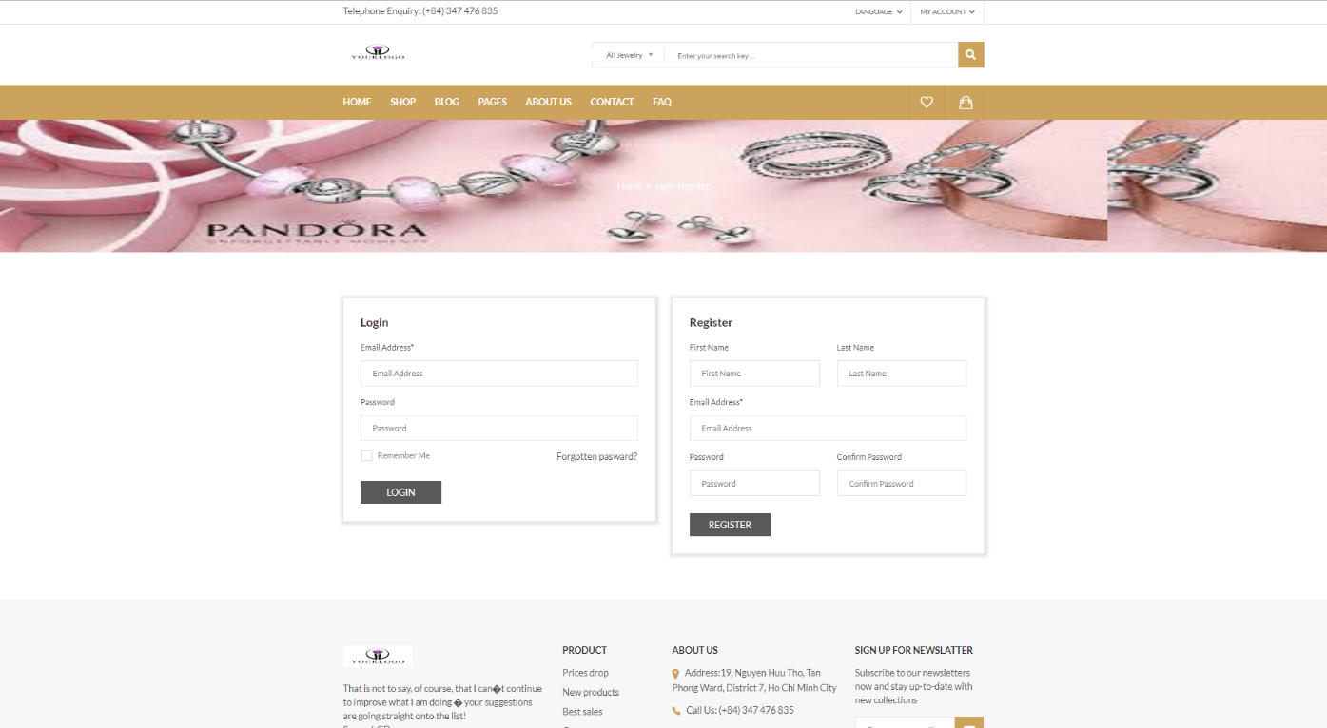

*Figure 38: UI of Login and Register page*

3.10 Error page

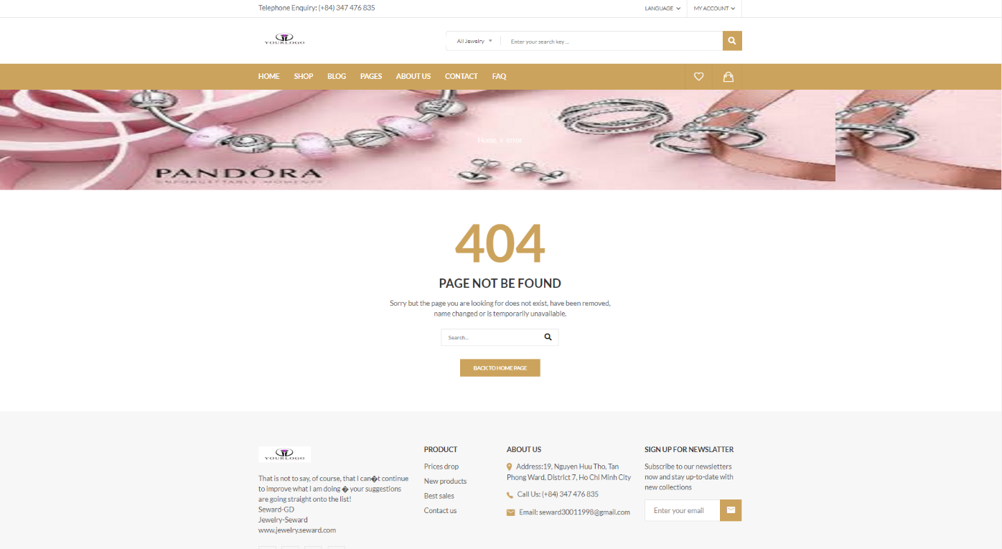

*Figure 39: UI of Error page*

CHAPTER 4 – IMPLEMENTATION

4.1 Source code structure

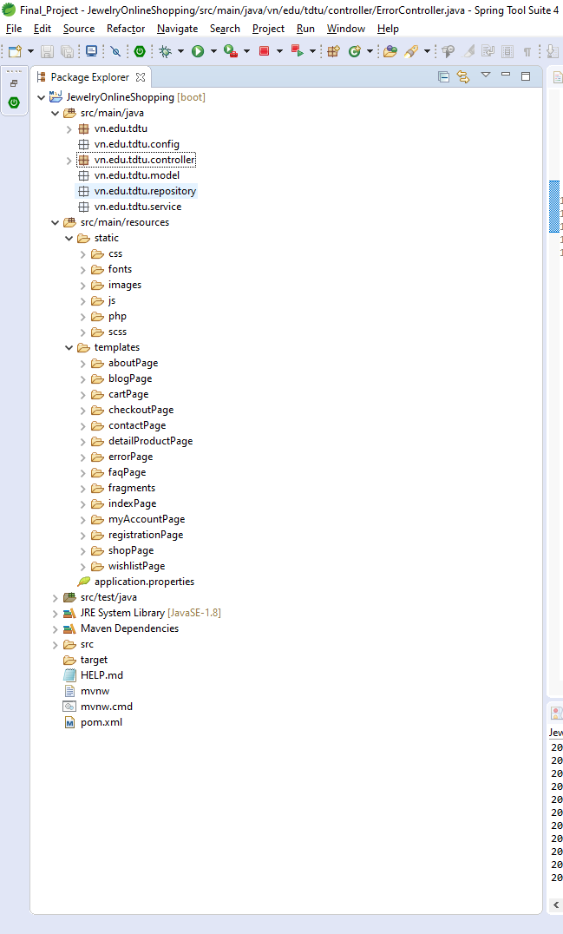

*Figure 40: Structure of source code*

4.2 Configuration

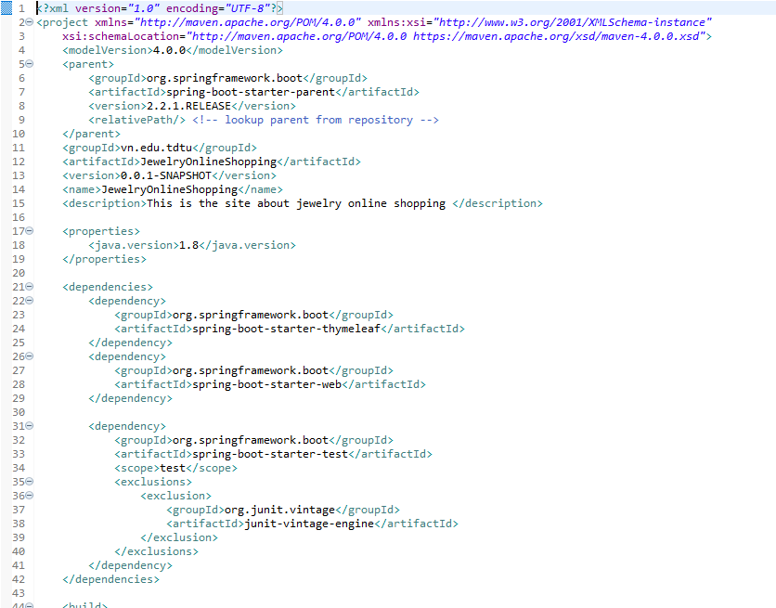

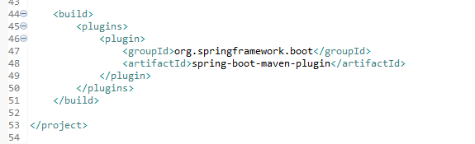

*Figure 41: File pom contains that I configure for project*

4.3 Code: java, css, html, js, …

4.4 Test

CHAPTER 5 – CONCLUSIONS/RECOMMENDATIONS

This sale system is just a functional process without complicated process so far.

The identified actors play an important role to the full functioning of the business.

The output product seems to satisfy all users but will certainly have to wait for the real consequences that the new system can produce. This project has been made user-friendly using basic images that allow users to interact easily with the database.

Finally, we would like to thank everyone who supported us in completing this project.

**REFERENCES**